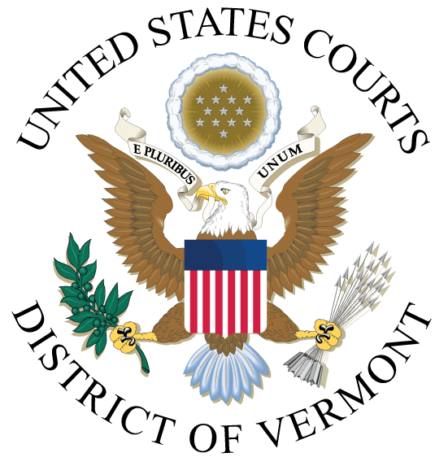

PUBLIC NOTICE OF CLOSURE

Due to the holiday, the Clerk's Offices (all locations) will be closed on the following dates:

Thursday, November 25, 2021
Friday, November 26, 2021

The court's Electronic Case Files (ECF) and Public Access to Court Electronic Records (PACER) systems will remain operational during the closure.

JEFFREY S. EATON
CLERK OF COURT

